ASSIGNMENT – 37

CODE:

CREATE OR REPLACE PROCEDURE compile_plsql(

p_name VARCHAR2,

p_type VARCHAR2,

p_options VARCHAR2 DEFAULT NULL

) IS

v_stmt VARCHAR2(4000);

BEGIN

v_stmt := 'ALTER ' || p_type || ' ' || p_name || ' COMPILE';

IF p_options IS NOT NULL THEN

v_stmt := v_stmt || ' ' || p_options;

END IF;

EXECUTE IMMEDIATE v_stmt;

EXCEPTION

WHEN OTHERS THEN

RAISE_APPLICATION_ERROR(-20001, 'Error compiling PL/SQL object: ' || SQLERRM);

END;

/

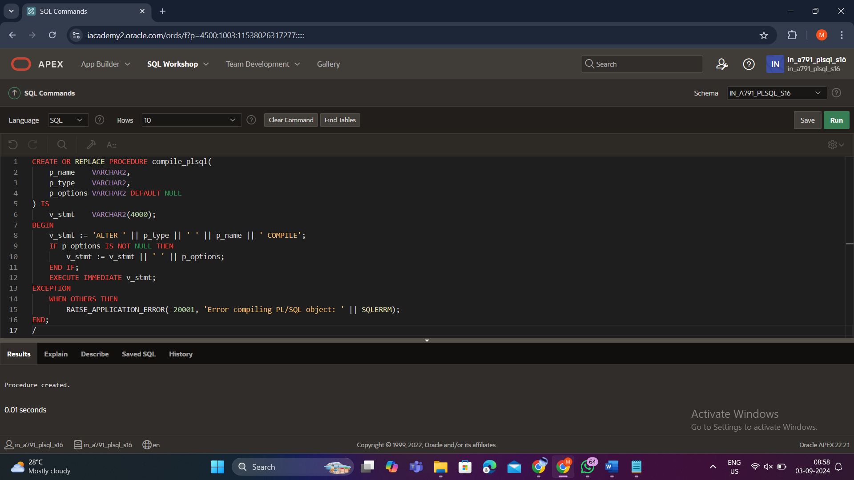

OUTPUT:

BEGIN

compile_plsql('format_phone', 'PROCEDURE');

compile_plsql('curs_pkg', 'PACKAGE', 'DEBUG');

END;

/

